What Happens in Heartworm Disease
The Pet Health Care Library
Heartworm Disease vs. Heartworm Infection
Before reviewing the clinical signs seen in heartworm disease, an important distinction must be made between heartworm disease and heartworm infection. Heartworm infection by definition means the host animal (generally a dog) is parasitized by at least one life stage of the heartworm (Dirofilaria immitis). Dogs with heartworms in their bodies do not necessarily have adult worms in their hearts; they may have larval heartworms in their skin only. Dogs with heartworms in their bodies are not necessarily sick, either. Dogs with only larvae of one stage or another are not sick and it is controversial how dangerous it is for a dog to have only one or two adult heartworms. These dogs are certainly infected but they do not have heartworm disease.
On the other hand, dogs with heartworm disease are sick. They not only have the infection but they have any of the problems listed below because of it. Fortunately, heartworm disease is both treatable and preventable. Further sections of this web page explain both treatment and prevention; we will now discuss the damage heartworms can do to a dog's body.
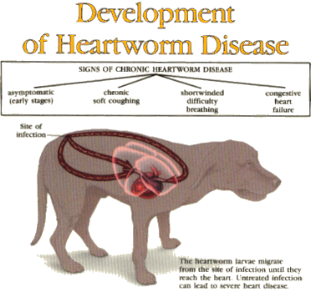

Damage to the Pulmonary Arteries
Arteries do not do well having worms living inside them. The lining of the artery becomes damaged within days of the worm's arrival. Cells of the immune system are called into the area but the worm is far too big for these tiny cells to destroy. The resulting inflammation; however, continues to damage the artery. The arteries dilate and become tortuous (which may be visible on a radiograph). Aneurysms and abnormal blood clotting (embolism) results. Blood is shunted to other arteries that are not plugged up by worms and fluid begins to accumulate in the lung around the worm-filled arteries. Blood being sent to the lung is not efficiently oxygenated and areas of lung become consolidated and unable to participate in providing oxygen to the blood.
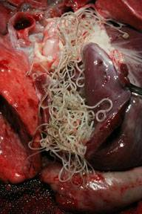
Heart and lungs affected by heartworms. ©Photo copyright Merial Limited, Duluth, GA, used with permission.

- Coughing and exercise intolerance result as areas of the lung are unable to participate in the blood oxygenation process.
- Nose bleeds may occur due to abnormal blood clotting in the lung.
- A form of non-infectious pneumonia (pulmonary eosinophilic granulomatosis) can result from excessive infiltration of inflammatory cells into the lung in response to the parasite.
Heart Failure
Blood normally is pumped with ease through the arteries of the lung. With the arteries plugged with worms, the heart must pump harder against the pressure of the plugged arteries. This condition is called pulmonary hypertension and the right side of the heart must drastically increase its ability to work. It may be strong enough and it may not.
If worms begin backing up into the heart, there will be less space in the pumping chamber for blood to be pumped. The heart must pump through the high pressure system of the plugged arteries using less blood then normal. In order to meet the body's oxygen demand, the heart must pump faster and stronger still. There may come a point when the heart simply is not strong enough.
- When the heart muscle begins to thicken (as any over-worked muscle will), it may not conduct electrical impulses normally. This means that the pumping/filling rhythm can be disrupted and an arrhythmia may result.
In any heart disease, arrhythmia is a possibility; when arrhythmia is a possibility, so is sudden death.
- If the right side of the heart becomes too weak to keep up, fluid may accumulate in the chest cavity and abdominal cavity, leading to a pot-bellied appearance and/or difficulty breathing.
Chronic Immune Stimulation
When a dog goes without treatment for heartworm disease, her immune system becomes chronically stimulated. Antibodies, which are not only important tools of the immune system but are inflammatory proteins, are produced in high amounts all the time. These antibodies can cause a lot of trouble by precipitating in the delicate membranes of the eye, kidney, blood vessels, and joints. Antibodies stuck in these areas, call in inflammatory cells and damage these delicate membranes thus setting up tremendous tissue damage and pain.
Caval Syndrome
Caval syndrome represents an especially disastrous form of heartworm disease. Here, there are so many worms (around 100) that the entire right side of the heart is filled with worms and they are backing out into the large veins that feed the right side of the heart. Usually there have been no signs of heart disease prior to the collapse, shock, and red blood cell destruction associated with this syndrome. Death usually occurs within 1 to 2 days and the only effective treatment is to open the dog's jugular vein and physically remove the worms with a special clamp. If enough worms can be removed to re-establish blood flow, the dog may survive.
Heartworm disease is a highly significant problem and must be managed both by dealing with the worms and by dealing with the heart disease.
Heartworm in Cats
Heartworm disease in cats is quite a bit different from heartworm disease in dogs. Cats are so small that only one adult worm could be enough to cause heart failure, plus there is much more inflammation involved with immature worms in cats. See details on heartworm infection, disease, treatment, and prevention in cats.

Copyright 2012 - 2016 by the Veterinary Information Network, Inc. All rights reserved.
Permanent Link: //www.VeterinaryPartner.com/Content.plx?P=A&A=591

